Activity-Based Learning (ABL) Case Studies Collection
Case study 1: Progressive Electricity Billing
1. Problem Statement: The program calculates electricity bills using tiered consumption slabs and validates the entered units.
2. Objectives: To compute electricity charges based on consumption slabs and display the total bill using Python.
3. Assumptions: Units consumed must be non-negative integers.
4. Algorithm:
1. Input electricity units consumed.
2. Validate that units are non-negative.
3. Calculate bill amount according to progressive consumption slabs.
4. Display units consumed and the calculated electricity bill.
5. Flow Chart
+-------------------------+
| START |
+-------------------------+
|
v
+-------------------------+
| Input Units Consumed |
+-------------------------+
|
v
/---------------------\
< Units < 0? >
\---------------------/
/ \
Yes No
/ \
+--------------------+ +----------------------------+
| Print: | | Compute Bill via Slabs |
| Invalid units | +----------------------------+
+--------------------+ |
+----------------------------+
| Display Units & Bill Amount|
+----------------------------+
|
v
+-------------------------+
| END |
+-------------------------+
6. Pseudo code
START
INPUT units
IF units < 0:
DISPLAY "Invalid units"
ELSE:
Calculate bill based on slabs (up to 100, 200, 300, and above)
DISPLAY units consumed and total bill
END IF
END
7. Source Code
units = int(input("Enter electricity units consumed: "))
if units < 0:
print("Invalid units")
else:
if units <= 100:
bill = units * 1.5
elif units <= 200:
bill = 100 * 1.5 + (units - 100) * 2.5
elif units <= 300:
bill = 100 * 1.5 + 100 * 2.5 + (units - 200) * 4
else:
bill = 100 * 1.5 + 100 * 2.5 + 100 * 4 + (units - 300) * 5
print("Units consumed:", units)
print("Electricity bill: Rs.", round(bill, 2))
8. Test Cases
Test Case | Input | Expected Output
1 | Units: 80 | Units consumed: 80, Electricity bill: Rs. 120.0
2 | Units: 150 | Units consumed: 150, Electricity bill: Rs. 275.0
9. Out Screenshots
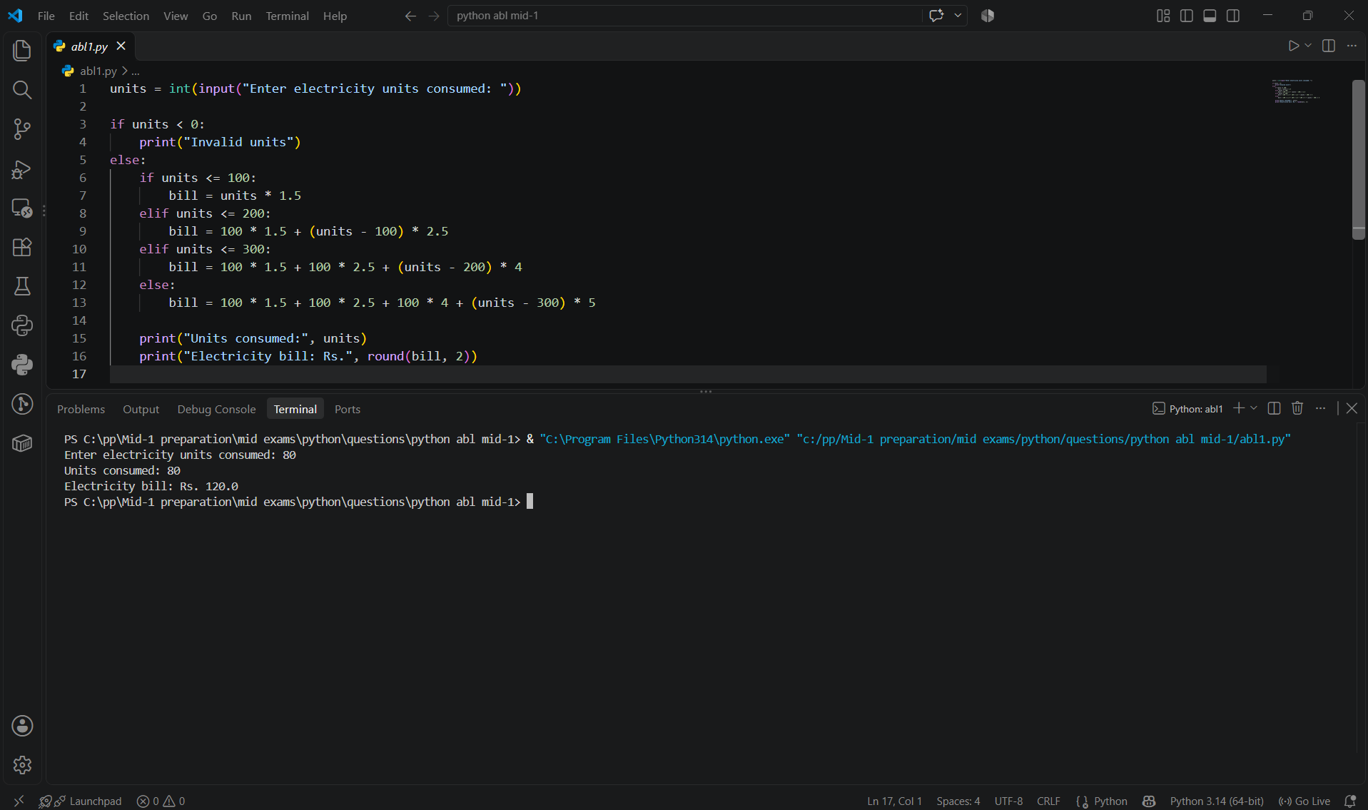

10. Conclusion: The program successfully computes tiered electricity bills based on consumption units.
Case study 2: Employee Payroll and Deduction Analysis
1. Problem Statement: The program calculates employee gross salary, determines deductions based on income slabs, computes net salary, and classifies the salary category.
2. Objectives: To compute gross earnings, deductions, net salary, and display a comprehensive salary statement using Python.
3. Assumptions: Basic salary, allowance, and overtime are non-negative numeric inputs.
4. Algorithm:
1. Input employee name, basic salary, allowance, and overtime.
2. Calculate gross salary as the sum of basic, allowance, and overtime.
3. Determine deductions based on gross salary slabs.
4. Compute net salary and display the statement with the salary category.
5. Flow Chart
+-------------------------+
| START |
+-------------------------+
|
v
+-------------------------+
| Input Name, Basic, |
| Allowance, Overtime |
+-------------------------+
|
v
+-------------------------+
| Calculate Gross Salary |
+-------------------------+
|
v
/---------------------\
< Apply Deduction Slabs >
\---------------------/
|
v
+-------------------------+
| Calculate Net Salary |
+-------------------------+
|
v
/---------------------\
< Net Salary >= 30000? >
\---------------------/
/ \
Yes No
/ \
+--------------------+ +----------------------------+
| Category: High | | Category: Regular |
+--------------------+ +----------------------------+
\ /
\ /
+--------+----------+
|
v
+-------------------------+
| END |
+-------------------------+
6. Pseudo code
START
INPUT name, basic, allowance, overtime
gross = basic + allowance + overtime
IF gross <= 20000: deduction = gross * 0.05
ELSE IF gross <= 40000: deduction = gross * 0.10
ELSE: deduction = gross * 0.15
net_salary = gross - deduction
DISPLAY salary statement, deductions, net salary, and category
END
7. Source Code
print("Employee Payroll")
name = input("Enter employee name: ")
basic = float(input("Enter basic salary: "))
allowance = float(input("Enter allowance: "))
overtime = float(input("Enter overtime amount: "))
gross = basic + allowance + overtime
if gross <= 20000:
deduction = gross * 0.05
elif gross <= 40000:
deduction = gross * 0.10
else:
deduction = gross * 0.15
net_salary = gross - deduction
print("\n--- Salary Statement ---")
print("Employee:", name)
print("Basic salary:", basic)
print("Allowance:", allowance)
print("Overtime:", overtime)
print("Gross salary:", gross)
print("Deduction:", deduction)
print("Net salary:", net_salary)
if net_salary >= 30000:
print("Salary category: High")
else:
print("Salary category: Regular")
print("Payroll calculation completed.")
8. Test Cases
Test Case | Input | Expected Output
1 | Name: John, Basic: 15000, Allowance: 3000, Overtime: 2000 | Gross: 20000.0, Deduction: 1000.0, Net: 19000.0, Salary category: Regular
2 | Name: Alice, Basic: 30000, Allowance: 5000, Overtime: 5000 | Gross: 40000.0, Deduction: 4000.0, Net: 36000.0, Salary category: High
9. Out Screenshots
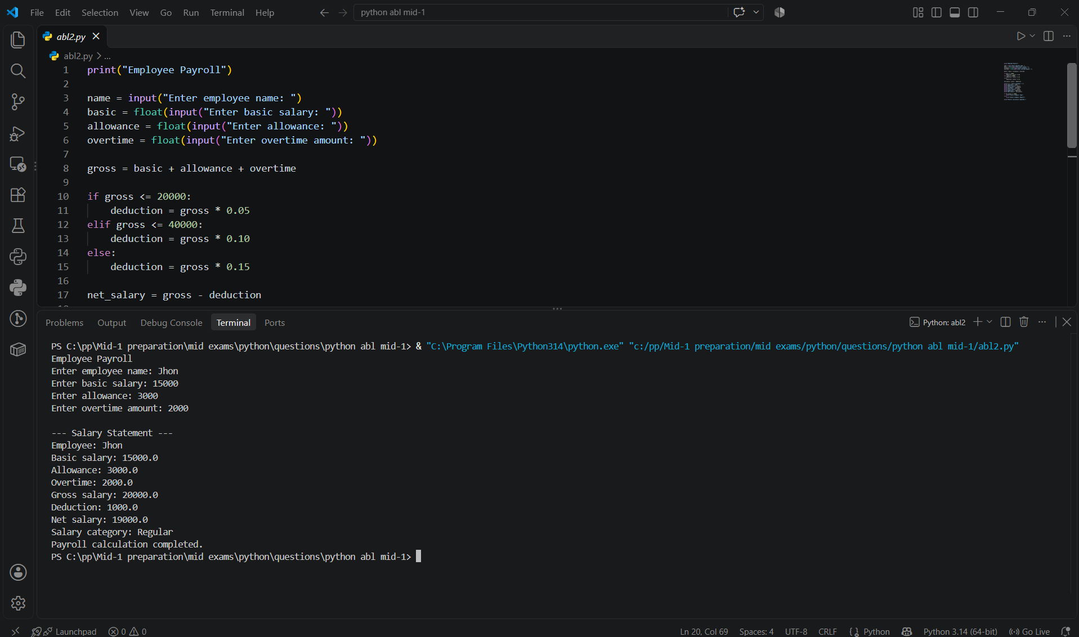

10. Conclusion: The program successfully automates employee payroll processing, deductions, and salary categorization.
Case study 3: Examination Result and Grace-Mark Validation
1. Problem Statement: The program records student marks for Python, Maths, and English, validates them, and computes the final pass/fail status and percentage.
2. Objectives: To input, validate, and evaluate subject marks to determine examination results.
3. Assumptions: Marks must be between 0 and 100.
4. Algorithm:
1. Input marks for all subjects.
2. Validate mark ranges and calculate total.
3. Evaluate pass/fail status and percentage.
5. Flow Chart
+-------------------------+
| START |
+-------------------------+
|
v
+-------------------------+
| Input Marks for Subjects|
+-------------------------+
|
v
/---------------------\
< Marks Valid? >
\---------------------/
/ \
No Yes
/ \
+--------------------+ +----------------------------+
| Print: | | Compute Total & Percentage |
| Invalid marks | +----------------------------+
+--------------------+ |
/---------------------\
< Passed (>=35)? >
\---------------------/
/ \
No Yes
/ \
+---------------+ +---------------+
| Result: Fail | | Result: Pass |
+---------------+ +---------------+
\ /
\ /
+--------+----------+
|
v
+-------------------------+
| END |
+-------------------------+
6. Pseudo code
START
FOR each subject: INPUT mark
IF marks between 0 and 100:
Calculate total and percentage
IF any mark < 35: DISPLAY Fail
ELSE: DISPLAY Pass
ELSE:
DISPLAY Invalid marks
END
7. Source Code
print("Examination Result")
marks = []
subjects = ["Python", "Maths", "English"]
for subject in subjects:
mark = int(input("Enter marks for " + subject + ": "))
marks.append(mark)
total = 0
failed = 0
for i in range(len(marks)):
if marks[i] < 0 or marks[i] > 100:
print("Invalid marks entered")
failed = -1
break
total = total + marks[i]
if failed == -1:
print("Please run the program again.")
else:
for mark in marks:
if mark < 35 and mark >= 30:
print("Grace marks applied to a subject")
elif mark < 35:
failed = failed + 1
if failed > 0:
print("Result: Fail")
else:
print("Result: Pass")
print("Total marks:", total)
print("Percentage:", round(total / len(marks), 2))
8. Test Cases
Test Case | Input | Expected Output
1 | Python: 80, Maths: 75, English: 90 | Result: Pass, Total: 245, Percentage: 81.67
2 | Python: 30, Maths: 40, English: 50 | Result: Fail, Total: 120, Percentage: 40.0
9. Out Screenshots
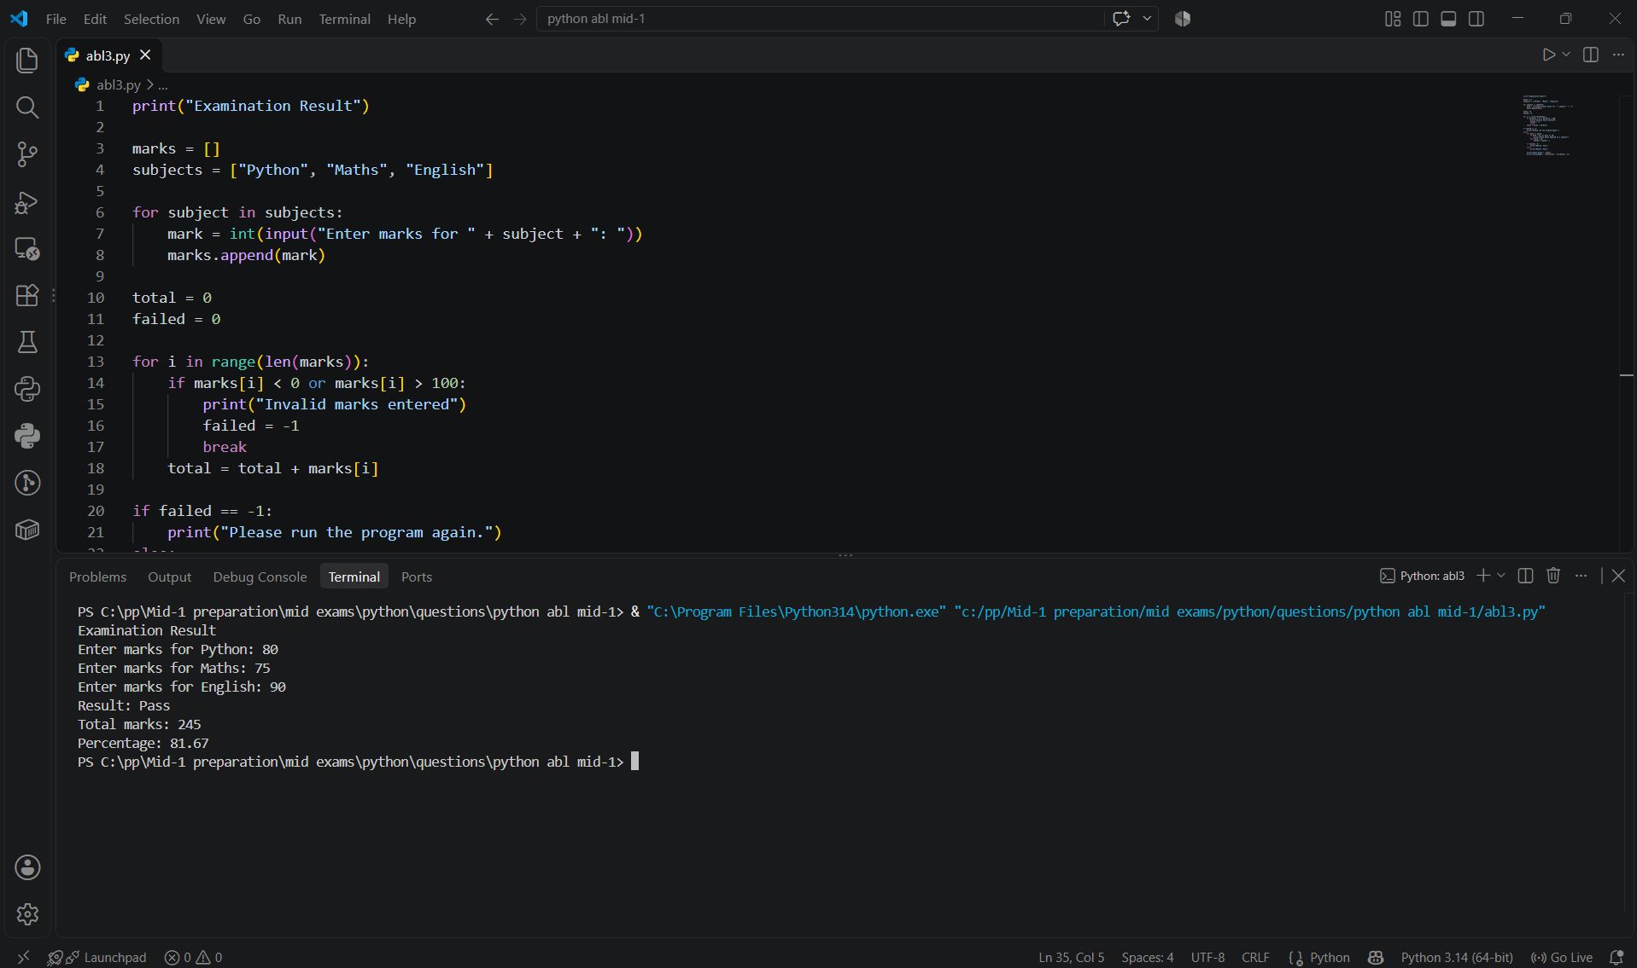

10. Conclusion: The program successfully evaluates examination results and percentages.
Case study 4: Food Waste Monitoring System
1. Problem Statement: The program tracks daily food preparation and consumption in a dining facility. It records meals prepared and served over five days, calculates waste percentages, and alerts if food wastage exceeds the threshold.
2. Objectives: To calculate daily food waste, total food served vs. prepared, overall wastage percentage, and evaluate efficiency using Python.
3. Assumptions: Meals prepared and served are non-negative integers, and the wastage threshold is set at 20%.
4. Algorithm:
1. Define the days list and initialize lists for prepared and served meals.
2. Loop through each day to input meals prepared and served.
3. Calculate waste per day and accumulate totals for prepared and served meals.
4. Calculate waste percentage: ((total_prepared - total_served) / total_prepared) * 100.
5. Check if waste percentage exceeds 20% and print the status message.
5. Flow Chart
+-------------------------+
| START |
+-------------------------+
|
v
+-------------------------+
| Initialize Days |
| prepared, served |
+-------------------------+
|
v
/------------------------------------\
< Loop for each day (Monday - Friday) >
\------------------------------------/
|
v
+-------------------------+
| Input prepared & served|
| Append to lists |
+-------------------------+
|
v
/------------------------------------\
< Calculate waste per day & Totals >
\------------------------------------/
|
v
+-------------------------+
| Calculate Percentage |
| ((Prep - Serv)/Prep)*100|
+-------------------------+
|
v
/---------------------\
< Percentage > 20% ? >
\---------------------/
/ \
Yes No
/ \
+--------------------+ +----------------------------+
| Print: | | Print: |
| High food wastage | | Food wastage within limit |
+--------------------+ +----------------------------+
\ /
\ /
+--------+----------+
|
v
+-------------------------+
| END |
+-------------------------+
6. Pseudo code
START
Initialize days, prepared, and served lists
FOR each day:
INPUT prepared and served meals
END FOR
Calculate daily waste, totals, and percentage
IF percentage > 20 THEN
DISPLAY "High food wastage"
ELSE
DISPLAY "Food wastage is within the limit"
END IF
END
7. Source Code
print("Food Waste Monitoring")
days = ["Monday", "Tuesday", "Wednesday", "Thursday", "Friday"]
prepared = []
served = []
for day in days:
print("\n", day)
p = int(input("Meals prepared: "))
s = int(input("Meals served: "))
prepared.append(p)
served.append(s)
total_prepared = 0
total_served = 0
for i in range(len(days)):
waste = prepared[i] - served[i]
total_prepared += prepared[i]
total_served += served[i]
print(days[i], "Waste:", waste)
if total_prepared > 0:
percentage = ((total_prepared - total_served)
/ total_prepared) * 100
else:
percentage = 0
print("\nTotal prepared:", total_prepared)
print("Total served:", total_served)
print("Waste percentage:", round(percentage, 2))
if percentage > 20:
print("High food wastage")
else:
print("Food wastage is within the limit")
8. Test Cases
Test Case | Input | Expected Output
1 | Prepared: 100, Served: 85 | Food wastage is within the limit
2 | Prepared: 100, Served: 70 | High food wastage
9. Out Screenshots
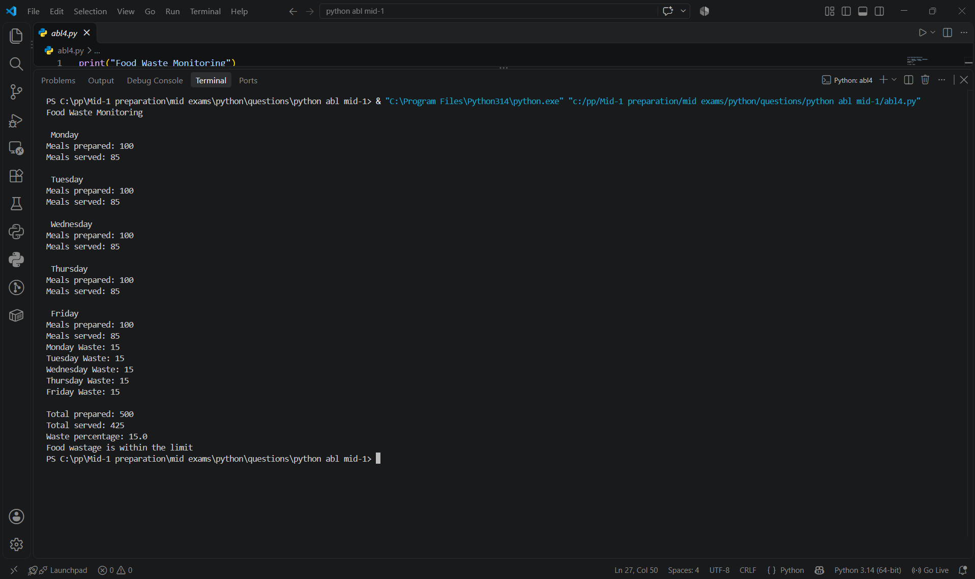

10. Conclusion: The program successfully tracks meal preparation and monitors food wastage levels.
Case study 5: Warehouse Inventory Reconciliation
1. Problem Statement: The program calculates closing stock for Pens, Books, and Bags using opening stock, received stock, and dispatched stock. It compares expected and actual stock, identifies shortages or surplus, and indicates when reordering is required.
2. Objectives: To monitor inventory levels, identify stock differences, and determine when products need reordering.
3. Assumptions: Stock quantities are entered as whole numbers. Reordering is required when actual closing stock is below 10 units.
4. Algorithm:
1. Initialize the product list.
2. Input opening, received, and dispatched stock.
3. Calculate expected closing stock.
4. Compare expected and actual stock.
5. Display shortage, surplus, or stock match and reorder status.
5. Flow Chart
+-------------------------+
| START |
+-------------------------+
|
v
+-------------------------+
| Initialize Products |
+-------------------------+
|
v
+-------------------------+
| Input Opening, Received,|
| Dispatched Stock |
+-------------------------+
|
v
+-------------------------+
| Calculate Expected Stock|
+-------------------------+
|
v
+-------------------------+
| Input Actual Stock |
+-------------------------+
|
v
/---------------------\
< Compare Act & Exp >
\---------------------/
/ | \
Equal More Less
/ | \
+---------------+ +---------+ +----------------+
| Stock matches | | Surplus | | Stock shortage |
+---------------+ +---------+ +----------------+
\ | /
+----------+---------+
|
v
/---------------------\
< Actual < 10? >
\---------------------/
/ \
Yes No
/ \
+--------------------+ +----------------------------+
| Reorder required | | Stock sufficient |
+--------------------+ +----------------------------+
\ /
+----------+----------+
|
v
+-------------------------+
| END |
+-------------------------+
6. Pseudo code
START
FOR each product:
INPUT opening, received, dispatched
expected = opening + received - dispatched
INPUT actual
difference = actual - expected
DISPLAY match, surplus, or shortage
IF actual < 10:
DISPLAY reorder required
ELSE:
DISPLAY stock sufficient
END
7. Source Code
print("Warehouse Inventory")
products = ["Pens", "Books", "Bags"]
opening = []
received = []
dispatched = []
for product in products:
print("\n", product)
opening.append(int(input("Opening stock: ")))
received.append(int(input("Stock received: ")))
dispatched.append(int(input("Stock dispatched: ")))
for i in range(len(products)):
expected = opening[i] + received[i] - dispatched[i]
print("\nProduct:", products[i])
print("Expected closing stock:", expected)
actual = int(input("Actual closing stock: "))
difference = actual - expected
if difference == 0:
print("Stock matches")
elif difference > 0:
print("Surplus stock:", difference)
else:
print("Stock shortage:", abs(difference))
if actual < 10:
print("Reorder required")
else:
print("Stock sufficient")
print("\nInventory checking completed.")
8. Test Cases
Test Case | Input | Expected Output
1 | Opening: 20, Received: 10, Dispatched: 5, Actual: 23 | Expected: 25; Shortage: 2; Stock sufficient
2 | Opening: 8, Received: 2, Dispatched: 5, Actual: 4 | Expected: 5; Shortage: 1; Reorder required
9. Out Screenshots
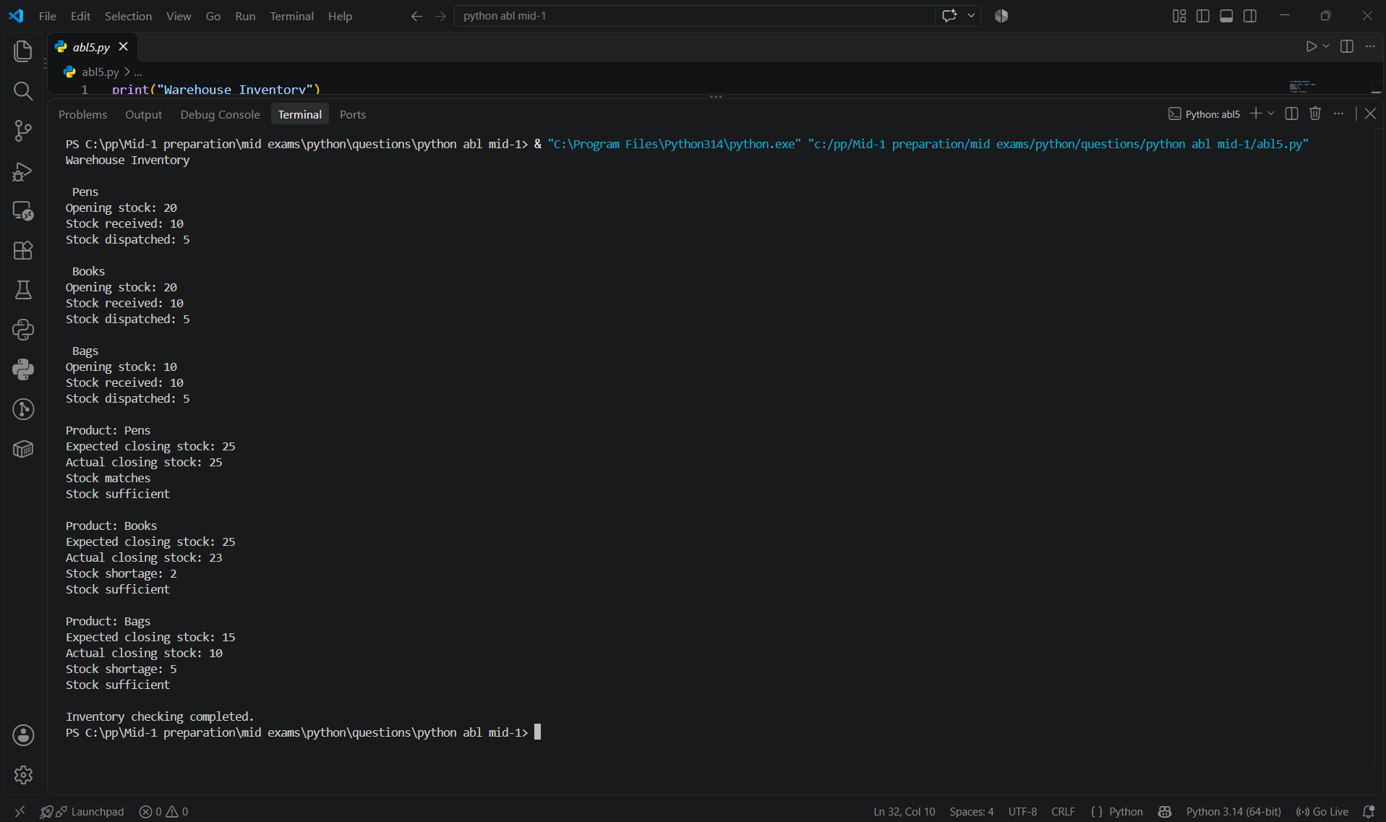

10. Conclusion: The program tracks inventory, detects stock differences, and identifies products that need reordering.
Case study 6: Student Timetable Conflict Detection
1. Problem Statement: Develop a Python program to identify timetable conflicts in a college or university. The program checks whether two classes are assigned the same room during the same period or whether the same course is scheduled more than once in the same period.
2. Objectives: To detect room and course scheduling conflicts using Python lists, nested loops, and conditional statements.
3. Assumptions: Each class has a course name, room number, and period number. A conflict occurs when two classes use the same room or the same course is scheduled twice during the same period.
4. Algorithm:
1. Start the program.
2. Create empty lists for courses, rooms, and periods.
3. Enter the number of classes.
4. Read the course name, room number, and period for each class.
5. Compare every pair of classes using nested loops.
6. If two classes have the same period and room, display a room conflict.
7. If the same course is scheduled twice in the same period, display a course conflict.
8. If no conflicts are detected, display a no-conflict message.
9. Display the complete timetable.
10. Stop the program.
5. Flow Chart
+-------------------------+
| START |
+-------------------------+
|
v
+-------------------------+
| Enter number of classes |
| and details |
+-------------------------+
|
v
+-------------------------+
| Compare each pair of |
| classes |
+-------------------------+
|
v
/---------------------\
< Same period and >
< same room? >
\---------------------/
/ \
Yes No
/ \
+--------------------+ |
| Print room conflict| |
+--------------------+ |
\ /
+----------+----------+
|
v
/---------------------\
< Same period and >
< same course? >
\---------------------/
/ \
Yes No
/ \
+-----------------------+ |
| Print course conflict | |
+-----------------------+ |
\ /
+----------+----------+
|
v
+-------------------------+
| Repeat for remaining |
| class pairs |
+-------------------------+
|
v
+-------------------------+
| If no conflict, print |
| no conflicts found |
+-------------------------+
|
v
+-------------------------+
| Display timetable & END |
+-------------------------+
6. Pseudo code
START
INPUT n
CREATE courses, rooms, periods lists
FOR i = 1 TO n
INPUT course, room, period
STORE details in lists
END FOR
conflict = False
FOR i = 0 TO n-1
FOR j = i+1 TO n-1
IF periods[i] = periods[j] THEN
IF rooms[i] = rooms[j] THEN
PRINT "Room conflict"
conflict = True
END IF
IF courses[i] = courses[j] THEN
PRINT "Course scheduled twice"
conflict = True
END IF
END IF
END FOR
END FOR
IF conflict = False THEN
PRINT "No timetable conflicts found"
END IF
DISPLAY timetable
PRINT "Checking completed"
STOP
7. Source Code
print("Timetable Conflict Checker")
courses = []
rooms = []
periods = []
n = int(input("Enter number of classes: "))
for i in range(n):
print("\nClass", i + 1)
course = input("Enter course name: ")
room = input("Enter room number: ")
period = input("Enter period number: ")
courses.append(course)
rooms.append(room)
periods.append(period)
conflict = False
for i in range(n):
for j in range(i + 1, n):
if periods[i] == periods[j]:
if rooms[i] == rooms[j]:
print("Room conflict:", courses[i], courses[j])
conflict = True
if courses[i] == courses[j]:
print("Course scheduled twice:", courses[i])
conflict = True
if conflict == False:
print("No timetable conflicts found")
print("\n--- Timetable ---")
for i in range(n):
print(courses[i], rooms[i], periods[i])
print("Checking completed.")
8. Test Cases
Test Case | Input / Condition | Expected Result
1 | Python and Maths assigned room 101 in period 1 | Room conflict detected
2 | Python in room 101, period 1; Maths in room 102, period 2 | No timetable conflicts found
9. Out Screenshots
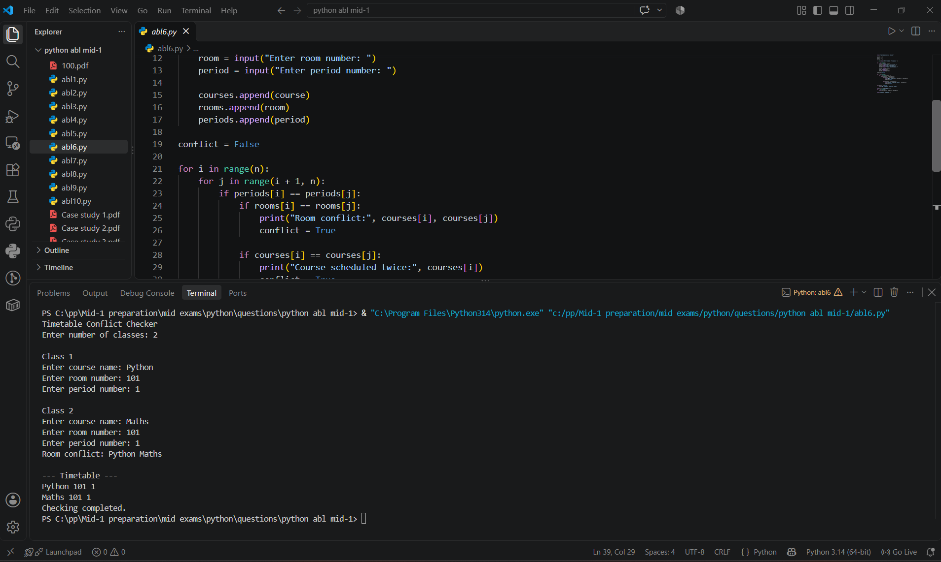

10. Conclusion: The Python program successfully identifies timetable conflicts by comparing course names, room numbers, and periods. It helps prevent scheduling errors and supports efficient timetable management.
Case study 7: Smart Canteen Order and Stock Management
1. Problem Statement: Develop a Python program to manage canteen orders, calculate total sales, and update available stock. The program should handle invalid choices and insufficient stock.
2. Objectives: To manage food orders, calculate bills, and track stock using Python loops and conditions.
3. Assumptions: The canteen sells Idli (Rs. 30), Dosa (Rs. 50), and Juice (Rs. 25) with initial stocks of 50, 30, and 40.
4. Algorithm:
1. Start the program.
2. Initialize items, prices, and stock.
3. Display the menu and accept an item choice.
4. If choice is 0, stop ordering.
5. Check the item choice and quantity.
6. Calculate amount and update stock if valid.
7. Repeat until the user exits.
8. Display total sales and remaining stock.
9. Stop.
5. Flow Chart
+-------------------------+
| START |
+-------------------------+
|
v
+-------------------------+
| Initialize items, prices|
| and stock |
+-------------------------+
|
v
+----> +-------------------------+
| | Display Menu & Input |
| | Choice |
| +-------------------------+
| |
| v
| /---------------------\
| < Choice == 0? >
| \---------------------/
| / \
| No Yes
| / \
| +--------------------+ +----------------------------+
| | Input quantity & | | Display total sales and |
| | validate stock | | remaining stock |
| +--------------------+ +----------------------------+
| | |
| v v
| +--------------------+ +----------------------------+
| | Compute amount & | | END |
| | update stock | +----------------------------+
| +--------------------+
| |
+--------+
6. Pseudo code
START
Initialize items, prices, stock
total = 0
WHILE TRUE
DISPLAY menu
INPUT choice
IF choice = 0 THEN BREAK
IF choice invalid THEN CONTINUE
INPUT quantity
IF quantity <= 0 THEN
PRINT "Invalid quantity"
ELSE IF quantity > stock THEN
PRINT "Not enough stock"
ELSE
amount = price * quantity
total = total + amount
UPDATE stock
PRINT amount
END IF
END WHILE
PRINT total sales and remaining stock
STOP
7. Source Code
print("Smart Canteen")
items = ["Idli", "Dosa", "Juice"]
prices = [30, 50, 25]
stock = [50, 30, 40]
total = 0
while True:
print("\nMenu")
for i in range(len(items)):
print(i + 1, items[i], prices[i], "Stock:", stock[i])
choice = int(input("Enter item number (0 to stop): "))
if choice == 0:
break
if choice < 1 or choice > len(items):
print("Invalid choice")
continue
quantity = int(input("Enter quantity: "))
index = choice - 1
if quantity <= 0:
print("Invalid quantity")
elif quantity > stock[index]:
print("Not enough stock")
else:
amount = prices[index] * quantity
total = total + amount
stock[index] -= quantity
print("Item:", items[index])
print("Amount:", amount)
print("\nTotal sales:", total)
print("Remaining stock:")
for i in range(len(items)):
print(items[i], stock[i])
print("Thank you!")
8. Test Cases
Test Case | Input | Expected Result
1 | Idli, quantity 2 | Amount: Rs. 60
2 | Dosa, quantity 35 | Not enough stock
9. Out Screenshots
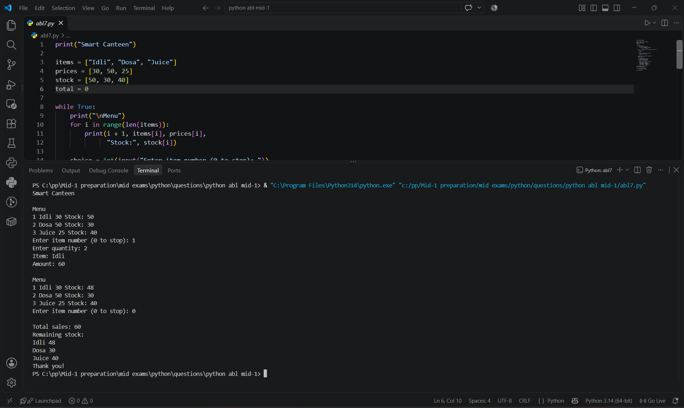

10. Conclusion: The program manages canteen sales, calculates bills, and updates stock using Python loops and conditional statements.
Case study 8: University Scholarship Allocation
1. Problem Statement: To develop a Python program to identify scholarship-eligible students based on marks, attendance, and family income. Eligible students are ranked in descending order of marks.
2. Objectives: To identify eligible students using specified criteria and rank eligible students by marks.
3. Assumptions: Marks must be at least 80%, attendance at least 75%, and family income at most Rs.2,00,000. Student details are entered correctly.
4. Algorithm:
1. Read student details.
2. Check eligibility criteria.
3. Store eligible students.
4. Sort them by marks in descending order.
5. Display the ranked list or a no-eligible-students message.
5. Flow Chart
+-------------------------+
| START |
+-------------------------+
|
v
+-------------------------+
| Enter number of students|
+-------------------------+
|
v
+-------------------------+
| Input Student details: |
| Name, Marks, Att, Income|
+-------------------------+
|
v
/---------------------\
< Check Eligibility? >
< Marks>=80, Att>=75, >
< Income<=200000 >
\---------------------/
/ \
Yes No
/ \
+--------------------+ +----------------------------+
| Add to eligible | | Ignore / Skip |
| list | +----------------------------+
+--------------------+ |
\ /
+--------------+--------------+
|
v
/---------------------\
< Eligible list empty? >
\---------------------/
/ \
Yes No
/ \
+--------------------+ +----------------------------+
| Display: No | | Sort by marks descending & |
| eligible students | | display ranked list |
+--------------------+ +----------------------------+
\ /
+----------+----------+
|
v
+-------------------------+
| END |
+-------------------------+
6. Pseudo code
START
Input student details
FOR each student
IF marks >= 80 AND attendance >= 75 AND income <= 200000
Add student to eligible list
Sort eligible students by marks descending
Display eligible students or "None found"
STOP
7. Source Code
print("Scholarship Allocation")
names, marks, attendance, income = [], [], [], []
eligible = []
n = int(input("Enter number of students: "))
for i in range(n):
print("\nStudent", i + 1)
names.append(input("Name: "))
marks.append(float(input("Aggregate marks: ")))
attendance.append(float(input("Attendance %: ")))
income.append(float(input("Family income: ")))
for i in range(n):
if marks[i] >= 80 and attendance[i] >= 75 and income[i] <= 200000:
eligible.append(i)
eligible.sort(key=lambda i: marks[i], reverse=True)
print("\nEligible students:")
for rank, i in enumerate(eligible, start=1):
print(rank, names[i], marks[i])
if not eligible:
print("No eligible students found")
else:
print("Scholarship candidates:", len(eligible))
print("Allocation checking completed.")
8. Test Cases
Test Case | Input | Expected Output
1 | Name: Ravi, Marks: 85, Attendance: 80%, Income: 1,50,000 | Eligible students: 1. Ravi - 85.0; Scholarship candidates: 1; Allocation checking completed.
2 | Name: Sita, Marks: 70, Attendance: 60%, Income: 2,50,000 | No eligible students found; Allocation checking completed.
9. Out Screenshots
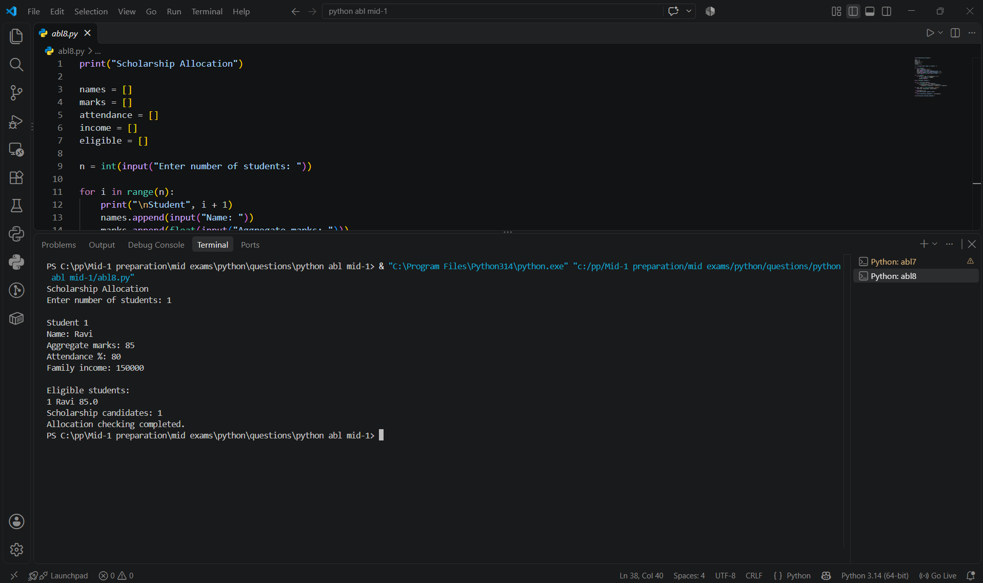

10. Conclusion: The Python program successfully identifies eligible scholarship candidates and ranks them according to their marks.
Case study 9: Campus Transport Allocation
1. Problem Statement: The program calculates the number of buses required for three campus routes based on passenger counts and bus capacity. It also displays total seats and unused seats.
2. Objectives: To allocate buses efficiently for each route and calculate the total and unused seats.
3. Assumptions: There are three routes: Route A, Route B, and Route C. Each bus has a positive capacity, and passenger counts cannot be negative.
4. Algorithm:
1. Initialize the three routes.
2. Input passengers and bus capacity for each route.
3. Validate the inputs.
4. Calculate buses required using ceiling division.
5. Display buses, total seats, and unused seats.
5. Flow Chart
+-------------------------+
| START |
+-------------------------+
|
v
+-------------------------+
| Initialize Routes |
+-------------------------+
|
v
+-------------------------+
| Input Passengers and |
| Bus Capacity |
+-------------------------+
|
v
/---------------------\
< Valid Inputs? >
< Pass>=0 & Cap>0 >
\---------------------/
/ \
Yes No
/ \
+--------------------+ +----------------------------+
| Compute Buses | | Mark Route Invalid |
| (Ceiling Division) | +----------------------------+
+--------------------+ |
| |
v |
+--------------------+ |
| Compute Total & | |
| Unused Seats | |
+--------------------+ |
\ /
+--------------+--------------+
|
v
+-------------------------+
| Display Buses & Seats |
+-------------------------+
|
v
+-------------------------+
| END |
+-------------------------+
6. Pseudo code
START
FOR each route:
INPUT passengers, capacity
IF passengers < 0 OR capacity <= 0:
buses = -1
ELSE:
buses = ceiling(passengers / capacity)
DISPLAY buses, total seats, unused seats
END
7. Source Code
print("Campus Transport Allocation")
routes = ["Route A", "Route B", "Route C"]
passengers = []
capacity = []
buses = []
for route in routes:
print("\n", route)
p = int(input("Number of passengers: "))
c = int(input("Capacity of one bus: "))
passengers.append(p)
capacity.append(c)
if p < 0 or c <= 0:
buses.append(-1)
else:
count = p // c
if p % c != 0:
count += 1
buses.append(count)
for i in range(len(routes)):
print("\nRoute:", routes[i])
if buses[i] == -1:
print("Invalid passenger count or capacity")
else:
print("Passengers:", passengers[i])
print("Buses required:", buses[i])
print("Total seats:", buses[i] * capacity[i])
print("Unused seats:", buses[i] * capacity[i] - passengers[i])
print("\nTransport allocation completed.")
8. Test Cases
Test Case | Input (Passengers, Capacity) | Expected Result
1 | 45, 20 | 3 buses, 60 seats, 15 unused seats
2 | -5, 20 | Invalid passenger count or capacity
9. Out Screenshots
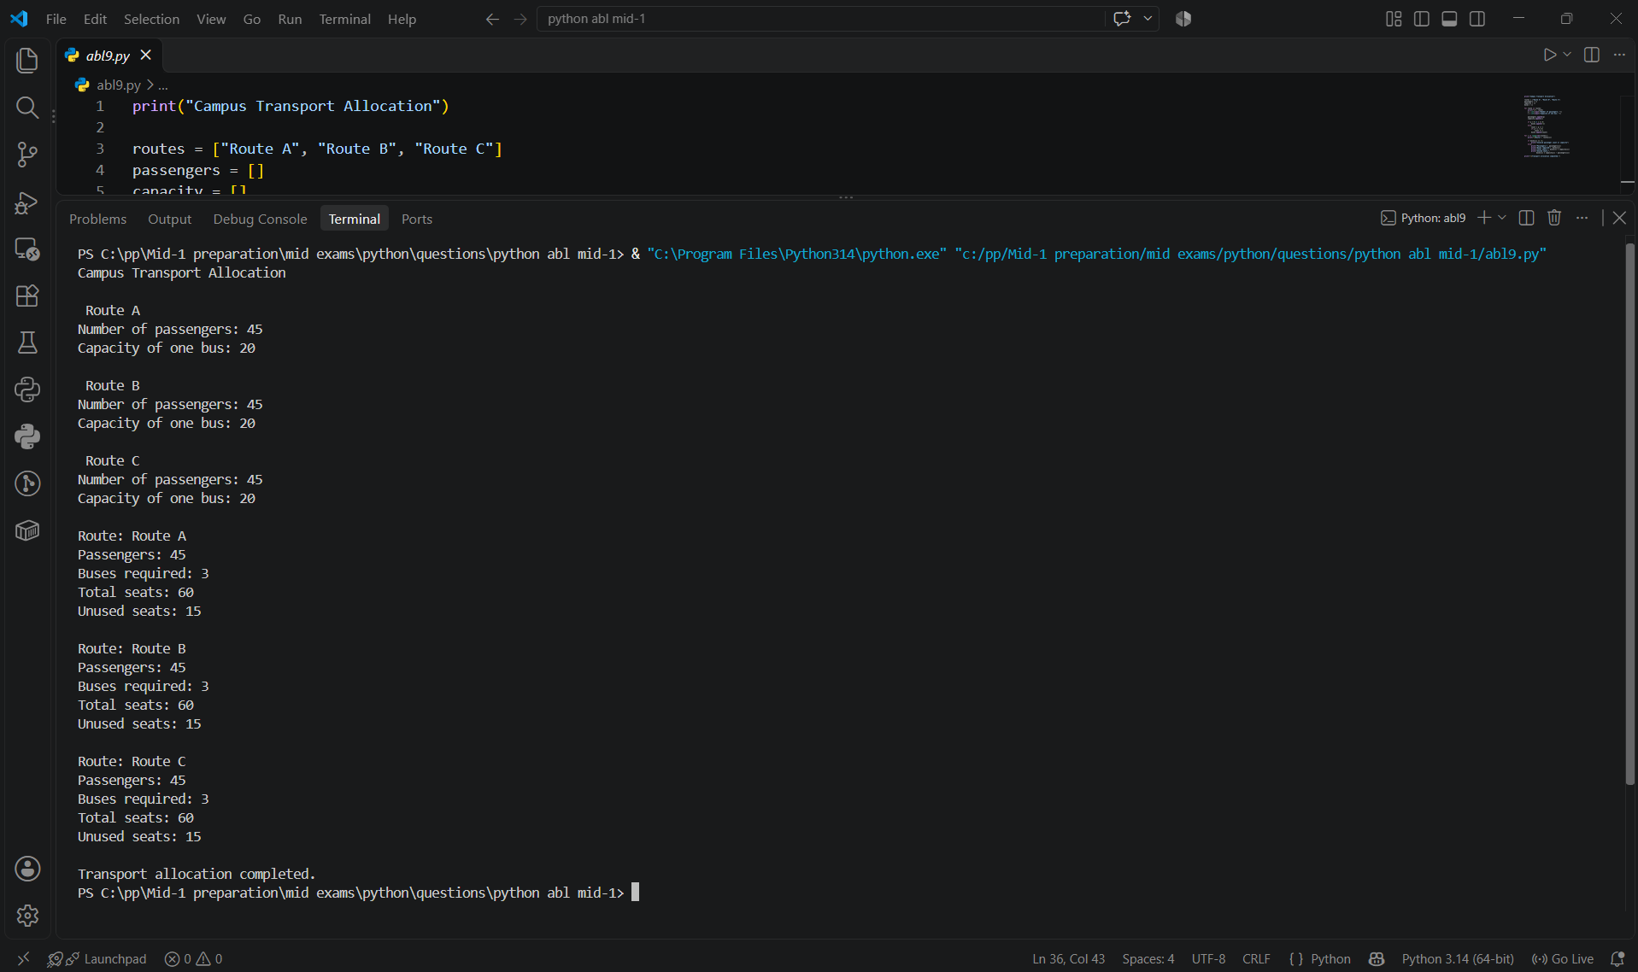

10. Conclusion: The program calculates the buses required for each route and displays seat details while handling invalid inputs.
Case study 10: Comprehensive Smart Campus Management Simulation
1. Problem Statement: The program manages student details, including names, attendance, and exam marks. It allows users to add students, display records, and check eligibility based on attendance and marks.
2. Objectives: To store student details, display records, and check eligibility using Python.
3. Assumptions: Attendance and marks must be between 0 and 100. A student is eligible if attendance is at least 75% and marks are at least 35.
4. Algorithm:
1. Initialize student lists.
2. Display the menu.
3. Add students, display records, or check eligibility based on the choice.
4. Repeat until Exit is selected.
5. Flow Chart
+-------------------------+
| START |
+-------------------------+
|
v
+-------------------------+
| Initialize Lists |
+-------------------------+
|
v
+----> +-------------------------+
| | Display Menu |
| +-------------------------+
| |
| v
| /---------------------\
| < Enter Choice >
| \---------------------/
| / | \ \
| Choice=1 Choice=2 Choice=3 Choice=4
| / | \ \
| +----------+ +----------+ +----------+ +-------+
| | Add | | Display | | Check | | END |
| | Student | | Students | | Results | +-------+
| +----------+ +----------+ +----------+
| \ | /
+--------+----------+----------+
6. Pseudo code
START
Initialize names, attendance, marks
REPEAT
Display menu
INPUT choice
IF choice = 1
Input student details, validate attendance and marks, save valid details
ELSE IF choice = 2
Display student records
ELSE IF choice = 3
Check attendance >= 75 and marks >= 35, display eligibility
ELSE IF choice = 4
Exit
ELSE:
Display invalid choice
UNTIL choice = 4
END
7. Source Code
print("Smart Campus Management")
names = []
attendance = []
marks = []
while True:
print("\n1. Add student")
print("2. Display students")
print("3. Check results")
print("4. Exit")
choice = input("Enter choice: ")
if choice == "1":
name = input("Student name: ")
att = float(input("Attendance percentage: "))
mark = float(input("Exam marks: "))
if 0 <= att <= 100 and 0 <= mark <= 100:
names.append(name)
attendance.append(att)
marks.append(mark)
print("Student added")
else:
print("Invalid attendance or marks")
elif choice == "2":
for i in range(len(names)):
print(names[i], attendance[i], marks[i])
elif choice == "3":
for i in range(len(names)):
if attendance[i] >= 75 and marks[i] >= 35:
print(names[i], "Eligible")
else:
print(names[i], "Not eligible")
elif choice == "4":
print("Exiting campus system")
break
else:
print("Invalid choice")
print("Program ended.")
8. Test Cases
Test Case | Input | Expected Output
1 | Name: Ravi, Attendance: 80%, Marks: 70 | Ravi Eligible
2 | Name: Sita, Attendance: 60%, Marks: 80 | Sita Not eligible
9. Out Screenshots
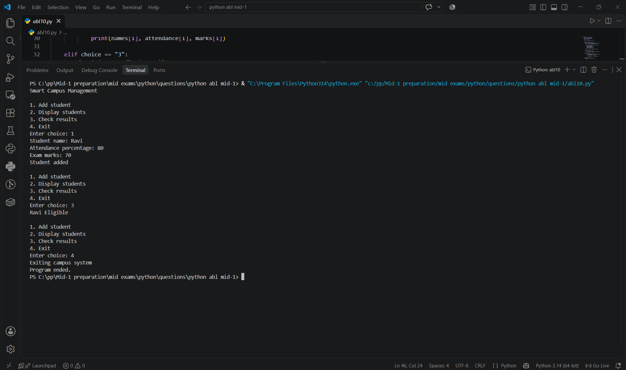

10. Conclusion: The Smart Campus Management program stores student details, displays records, and checks eligibility based on attendance and marks.

